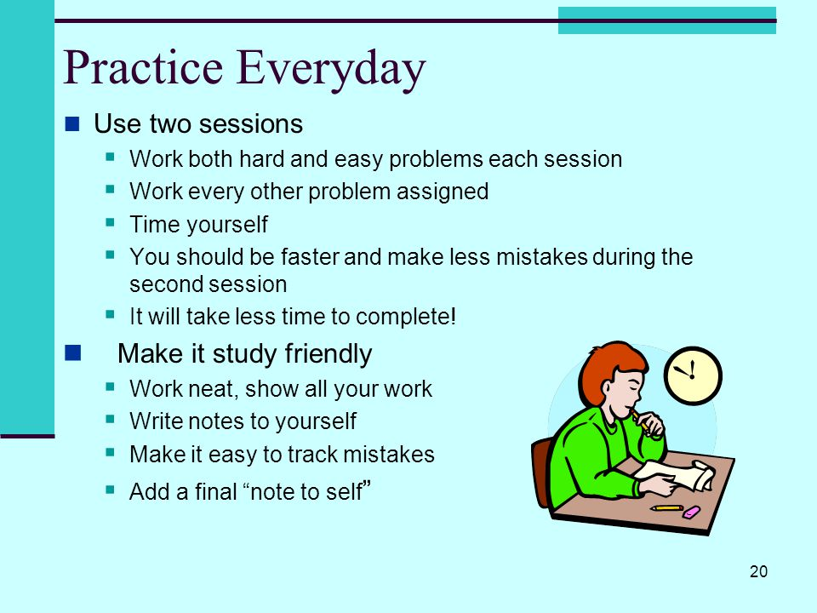

FOCUS 3

Modules
1, 2, 3

Revision - Keys

1. I don’t mind lending my bike to my friends.
I don’t mind lending my friends my bike.
2. Do you need a new pair of trainers?
3. They had an argument / They argued / They fell out last year, they haven’t
seen each other since then.
4. Do your last year’s clothes still fit you?
5. Are you kidding? No, she is not 70 years old.
6. You should focus on 2 areas: grammar and vocabulary.
7. I can’t put up with her bad mood every morning, she should make an effort.
8. In my opinion / I think that / To me, female athletes should earn the same
salary as male athletes.
9. How often do you go to the dentist(‘s) ?
10. I don’t put any sugar in my coffee, I am on a diet.
11. How long have you been going to the same doctor?
12. How far (away) is the nearest ski resort?
13. Suddenly, I heard a noise, I was afraid / I got scared but it was just an
animal under a tree.
14. When did your parents learn to swim?
15. He received a red card during the first half of the match.
16. I (have) inherited my small feet from my mother / I (have) inherited my
mother’s small feet but I look like my father / I resemble my father.
17. When I went to the United States, there were so many traffic jams to reach
the airport that I nearly / almost missed the plane.
18. I have never taken the wrong train.
19. There are few eggs in the fridge. / There are not many (a lot of) eggs in the
fridge.
20. My grand-mother has had this armchair for ages. It’s old but comfortable.
21. It has been too hot since the beginning of the summer, I can’t study.
22. We lived on a boat for 3 weeks in July, my sister didn’t like it at all.
23. Old people sometimes forget to drink as much water as they can.
Do they realize that it can be dangerous for their health?
24. My parents were not convinced that I had worked enough to pass my year in
June, they were right. Today, I have decided to prove that I can manage my
studies.
25. I had never had such a life lesson before.
26. You should spend your holiday in Spain. There are stunning views, fantastic
beaches and you eat very well there / the food is excellent there.
27. Do we need to have / share a lot of / lots of / plenty of / many
similar interests to our close friends // the same interests as our close
friends to get on well together?
28. I need some / a few eggs to prepare the dessert. Are there any left in the
fridge?
29. Has your mum bought her new car yet?
30. Don’t trust them. They have never been reliable.
31. – Listen! Have you heard that strange noise?
- Don’t worry! It must be a domestic animal. I have just seen a cat in the
garden.
32. - When did your parents make up their mind / make their mind up to go and
live in the countryside? - Four years ago.
33. He has never been able to overcome his disability, that’s a pity.
34. How long did it take you to get / go to school when you were a child?
35. Even if / although I had booked my ticket, I could not catch the first train
because I had arrived too late at the station.
36. Have you ever turned up at a party that you were not invited to?
37. Why is she wearing hiking boots?
38. You reveal something about your personality each time you change your
Facebook profile photo, don’t you?
39. - Do you know that John’s father is a teacher? – No, I don’t.
40. We were crossing the street when we saw them. They looked terrified.
41. - What clothes do boys usually wear to take an oral examination?
- A suit, a shirt and a tie are items that / which are worn in these
circumstances.
42. Eddy Merckx was less than 30 (years old) when he won the world cycling
championship.
43. I would like to speak three foreign languages. I will do my best to reach /
achieve that goal / objective / target.
44. She may / might / could be ill. I have not seen her for two days.
45. - What are you looking at?
- I am checking my translations before correcting them.
I hope (that) I haven’t made any mistake!

____________________________________________________________

